LabVIEW Adapter: Create Enumeration dialog

Description
Test enumerations in the LabVIEW adapter.

Preparation
- Install LabVIEW 2012 or a later version.(For LV test iteration install LV version under test).
- The media files are located at http://teststand.ni.com/testcases/Adapters/LabVIEW/Media/EnumControls
- Make all the files writeable and mass compile them with the installed version of LV
- Set the LV adapter to use the LabVIEW Development System

Validation

Standard Dialog Tests

Perform the standard dialog test for the create enum dialog.
Refer :
http://teststand/TestCases/StandardTest/Dialogs.html
Creating TestStand Enums
- Select the step Creating TestStand Enums.
- Click the button to create a custom data type for the first parameter.
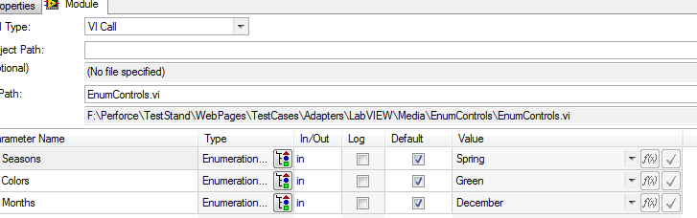
- On the Create tab, click the help button and verify a relevant help topic is shown.
- Close the Help dialog.
- Verify the table shows the same enumerators that are in the LabVIEW type.
- Click on the Update tab and verify there are no custom data types to update.
- Click on the Help button and verify a relevant help topic is shown.
- Click cancel. Verify no type was created and that no types were modified.
- For each parameter:
  - Click the button to create a custom data type.
  - Check that the Update tab shows all the types that were previously created.
  - On the Create tab, click Create. Verify the type was properly created. It should have the correct enumerators.
  - The value in the Types View for the new type should match the default value in the VI.
  - Click the Undo button and verify the type is removed.
  - Click the Redo button and verify the type has been added again.

Setting the Value to an Enum Variable
- Select the step Setting the Value to an Enum Variable.
- Create local variables from the custom data types just created.
- Map the parameters to the appropriate local variable just created.
- Verify the value for each parameter is valid.
- Verify the analyzer shows no errors for that step.
- Verify the step executes without throwing an exception.
Updating TestStand Enums
- Select the step Updating TestStand Enums.
- Change the VI to UpdatedEnumControls_new.vi.
- Verify that each the value of each parameter is displayed in red and has a tool tip stating that the enums must match exactly.
- Verify the analyzer shows an error about prototype error.
- Click the button to create/update a custom data type for the first parameter.
- On the Update tab, click the help button and verify a relevant help topic is shown.Close the Help dialog.
- Verify that the update tab lists only the enum types.
- Verify the table shows correctly lists the difference in enumerators of LabVIEW and TestStand enum you select (you should be able to select different TestStand enum types).
- Click cancel. Verify no type was created and that no types were modified.
- For each parameter:
  - Click the button to create/update a custom data type.
  - Check that the Update tab shows all the types that were previously created.
  - On the Update tab, click Update. Verify the type was properly updated. It should have the correct enumerators and the representation should be 64-bit Floating Point. All instances of the type should be updated as well.
  - The value in the Types View for the new type should match the default value in the VI.
  - No undo item should be created for the update.
- For a parameter, change the cluster passing values (like ‘allow objects to be passed’ property, ‘exclude when passing cluster’ property) in all the adapters. Now after updating the enumeration the cluster passing values should be retained. See CAR 617417 for reference.
Cluster with Enum
- Select the step Cluster with Enum.
- Click the button to create a custom data type for the cluster.
- Verify the table shows the enumeration and gives the user the option to create a new data type or just create a number.
- Select the option to create a number.
- Click Create.
- Verify a new custom container was created with a number in the place of the enum.
- Click undo and verify the type is removed.
- Click the button to create/update a custom data type for the cluster.
- Select the option to create a new enum data type.
- Click Create.
- Verify a new custom container and a new custom enum were created and that the container has an instance of the custom enum type.
- Click undo and verify both types are removed.
- Click redo and verify both types are added again.
- Click the button to create/update a custom data type for the cluster.
- Select the option to create an instance of the enum type you just created (it should appear in the drop down with the options to create a new type or to create a number).
- Change the name of the type to be created.
- Click create.
- Verify a new container type is created, but no new custom enum type is created. Verify the new container type has an instance of the custom enum type.
Verify that a enum created from a LV enum is strict by default and loose for a LV ring
- Create a VI with a Ring and an Enum type and connect them to terminal pane.
- Call this vi from TestStand
- Create an enum type in TestStand for both LV enum and LV ring
- While creating observe the strict enumeration flag is enabled for LV enum and disabled for LV ring by default ( shown below is an example of strict enum flag disabled).
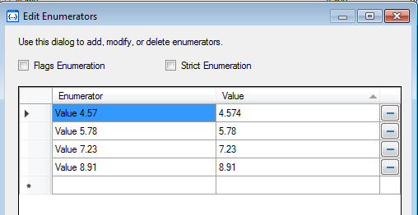
Creating Data Types in different Files
- Select the step Cluster with Enum.
- In the create\update custom data type dialog select current sequence to the create the custom data type as shown below :
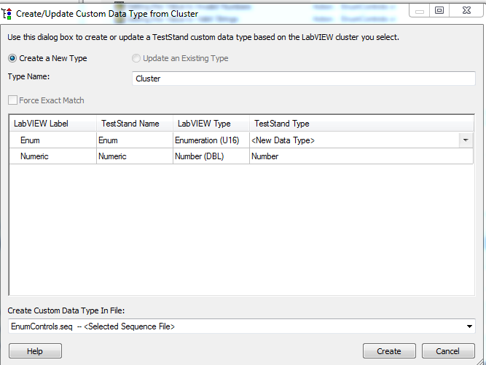

- Go to type palettes (CTRL+T) and ensure that the new type is created under custom data types for the test sequence.
- Select mytpes.ini and repeat the above and ensure that the custom data types is created in mytypes.ini.

Save for previous
- Save EnumControls.seq for previous version of TestStand.( older than TS 2016)
- Check that the enums are converted to numeric types.

.

National Instruments Confidential
Copyright © 2015 National Instruments Corporation

